Sensor Cloud Middleware

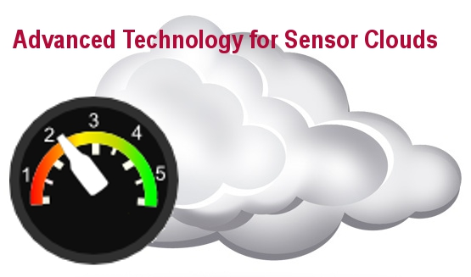
The Pervasive Technology Institute, Anabas, Inc. and Ball Aerospace have partnered to develop a Sensor-Centric Grid Middleware Management System called the Sensor Cloud which will soon be released as an open source project. The Sensor Cloud Project includes a highly scalable middleware which handles the transmission and routing of sensor data and a robust application API which you can use to extend our system with your own custom sensors and client applications. The Sensor Cloud has an intuitive interface for setting sensor policies as well as easy deployment and management of sensors across global networks. Because Sensor Cloud middleware was designed using the publish/subscribe design pattern it supports loosely-coupled, reliable, scalable communication between sensors and clients. By using the Sensor Cloud API’s simple integration interface it is possible add many third party application clients and sensors to the Sensor Cloud.

CTS Sessions related to the Sensor Cloud Project:

- Toward Securing Sensor Clouds Apu Kapadia, Steven Myers, Xiao Feng Wang and Geoffrey Fox
Session C1, Talk #3
Tues 10:20am to 12:00pm University Suite I/II

- Measured Characteristics of FutureGrid Clouds for Scalable Collaborative Sensor-Centric Grid Applications Geoffrey C. Fox, Alex Ho, Eddy Chan
Session A10, Talk #4
Wed. 1:20pm to 3:20pm Ben Franklin IV/V

For more information please visit our website at:
The Pervasive Technology Institute at Indiana University is pleased to announce the Sensor Cloud Middleware will soon be released as open source software.

https://sites.google.com/site/sensorcloudproject/

